Riphah International University
I-14 Campus Islamabad
Lab_Task_06
Department: Data Science
Subject: Data Structure
Submitted By:
Hammad Sajjad Awan
SAP ID:
76142
Submitted To:
Junaid Khan
Date Of Submission:
10/07/2026

Lab Report
Lab Activity 01:
Activity 1 — Infix to Postfix
Task
Write a Java program that converts an Infix expression into Postfix notation using a Stack.
Implement:
infixToPostfix(String expression)
Requirements
The program should:
- Read the expression from left to right.
- Add operands directly to the output.
- Push operators onto the Stack.
- Compare operator precedence.
- Handle opening and closing parentheses.
- Pop remaining operators from the Stack.
- Display the final Postfix expression.
Example
Input:
A + B * C
Output:
A B C * +
Test the program with at least three expressions.
Solution:
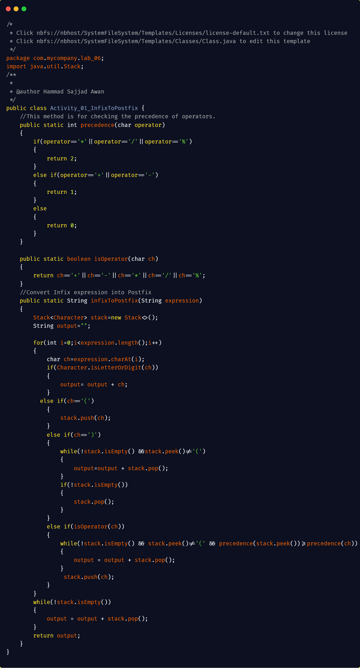
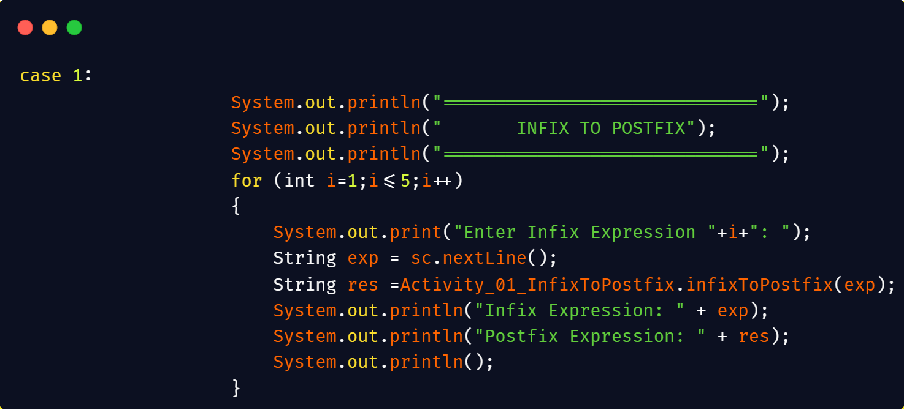
Output:
5 Expressions:
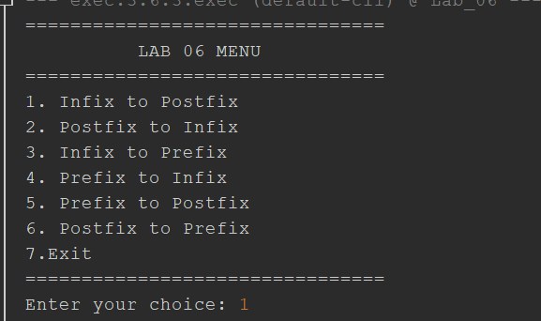
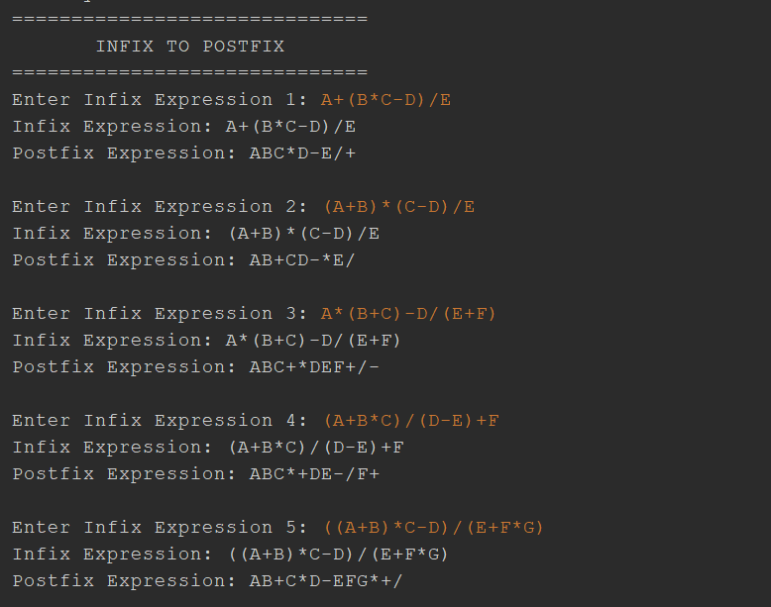

Lab Activity 02:
Activity 2 — Postfix to Infix
Task
Write a Java program that converts a Postfix expression into an Infix expression using a Stack.
Implement:
postfixToInfix(String expression)
Basic Algorithm
Read the Postfix expression from left to right.
- If the symbol is an operand, push it onto the Stack.
- If the symbol is an operator:
  - Pop the top operand.
  - Pop the second operand.
  - Place the operator between them.
  - Enclose the resulting expression in parentheses.
  - Push the resulting expression back onto the Stack.
- Continue until the expression ends.
- The final Stack element is the Infix expression.
Example
Postfix:
A B C * +
Result:
(A + (B * C))
Another Example
Postfix:
A B + C *
Result:
((A + B) * C)
Solution:
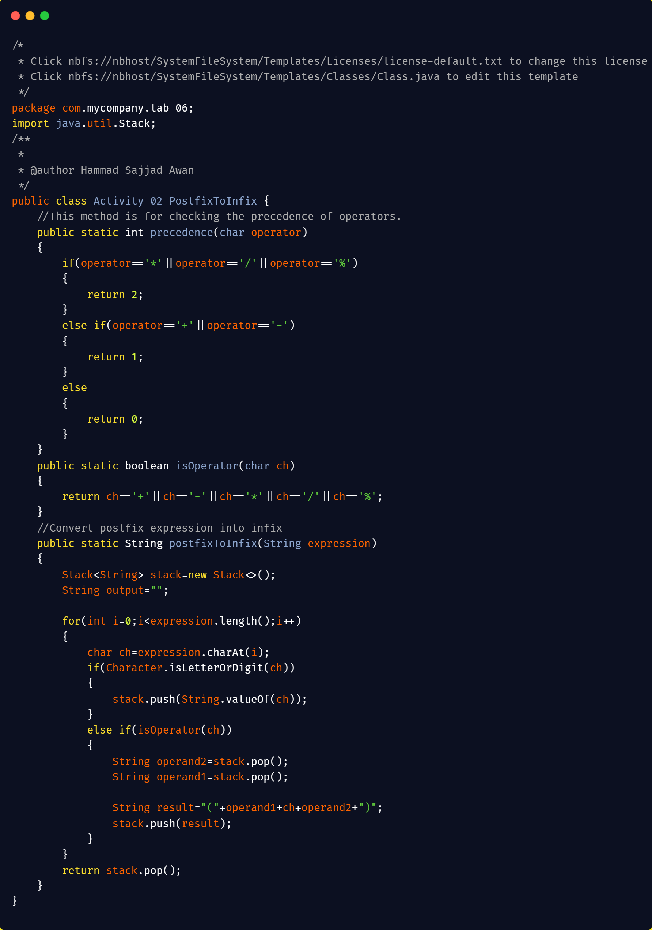

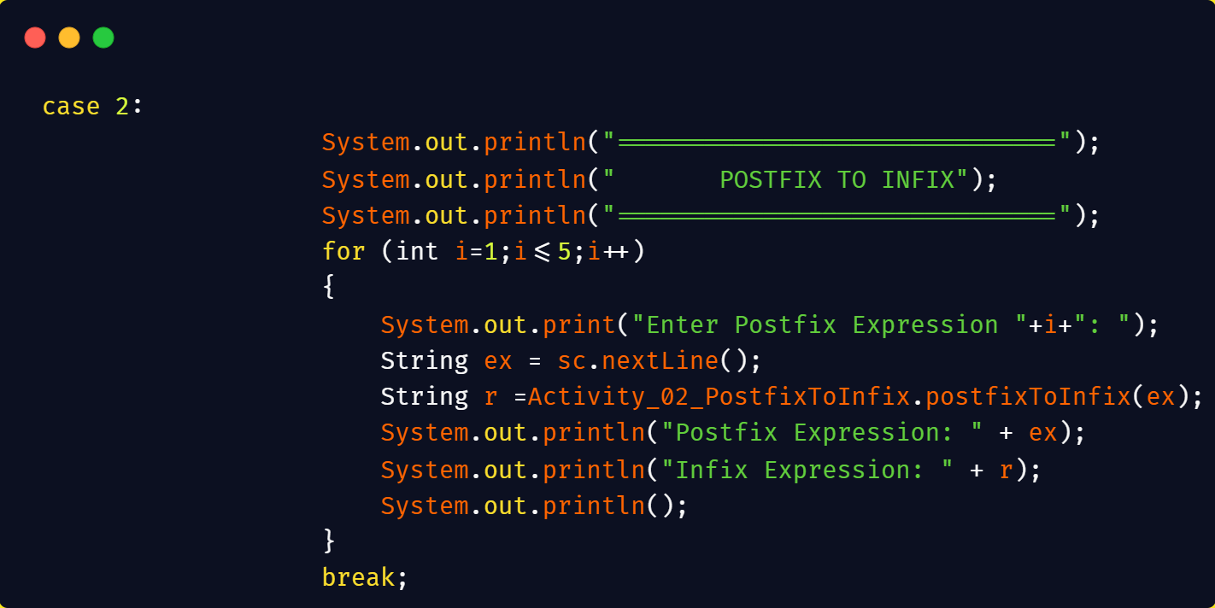
Output:
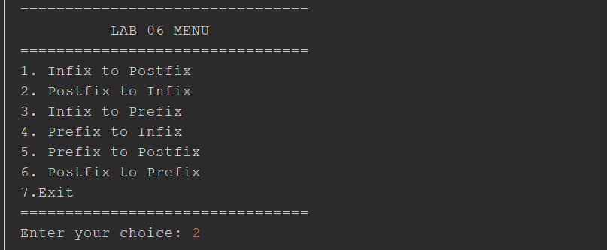
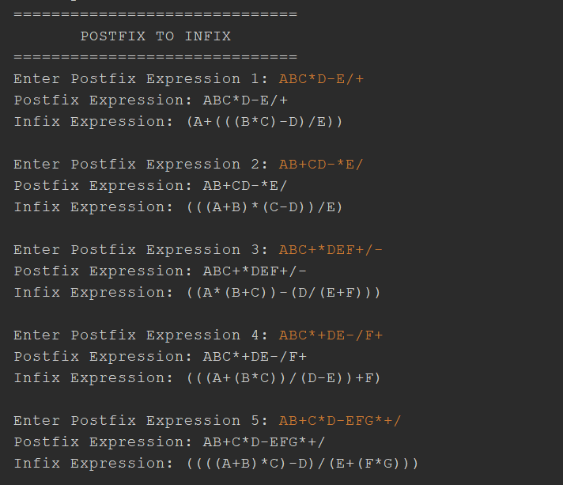

Lab Activity 03:
Activity 3 — Infix to Prefix
Task
Write a Java program that converts an Infix expression into Prefix notation using a Stack.
Implement:
infixToPrefix(String expression)
Requirements
The program should:
- Read an Infix expression.
- Handle parentheses.
- Apply operator precedence.
- Use a Stack during conversion.
- Produce the corresponding Prefix expression.
Example
Infix:
A + B * C
Prefix:
+ A * B C
Example 2
Infix:
(A + B) * C
Prefix:
* + A B C

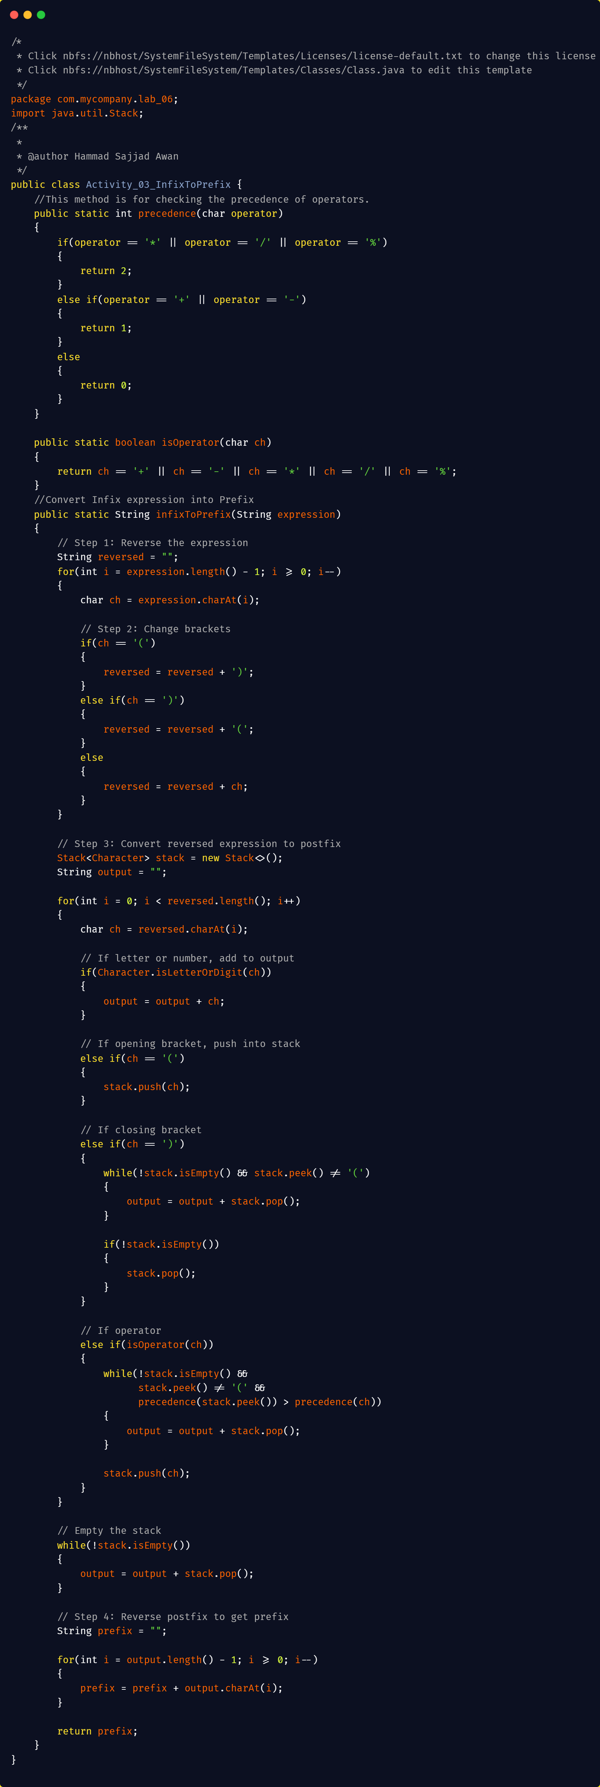
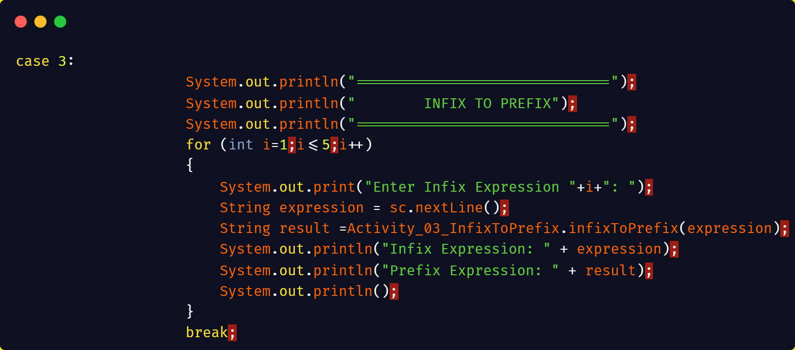
Output:
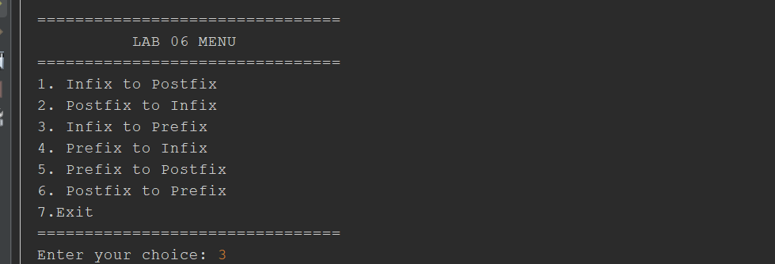
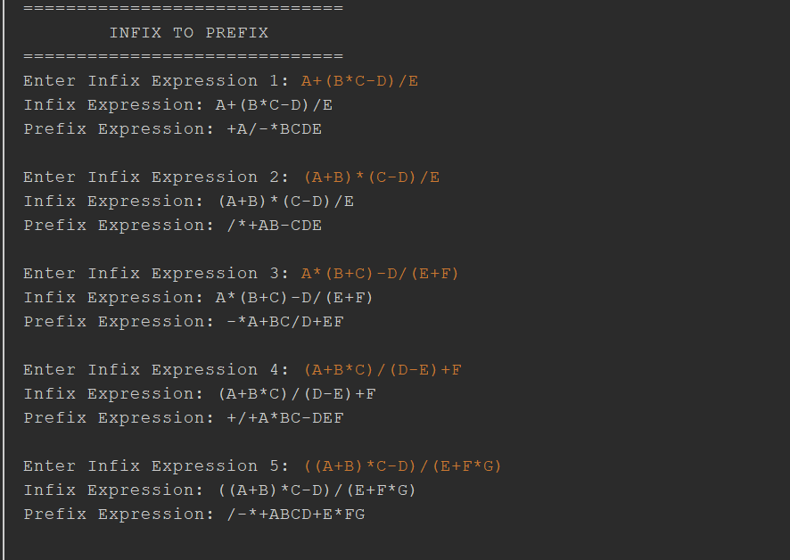
Lab Activity 04:
Activity 4 — Prefix to Infix
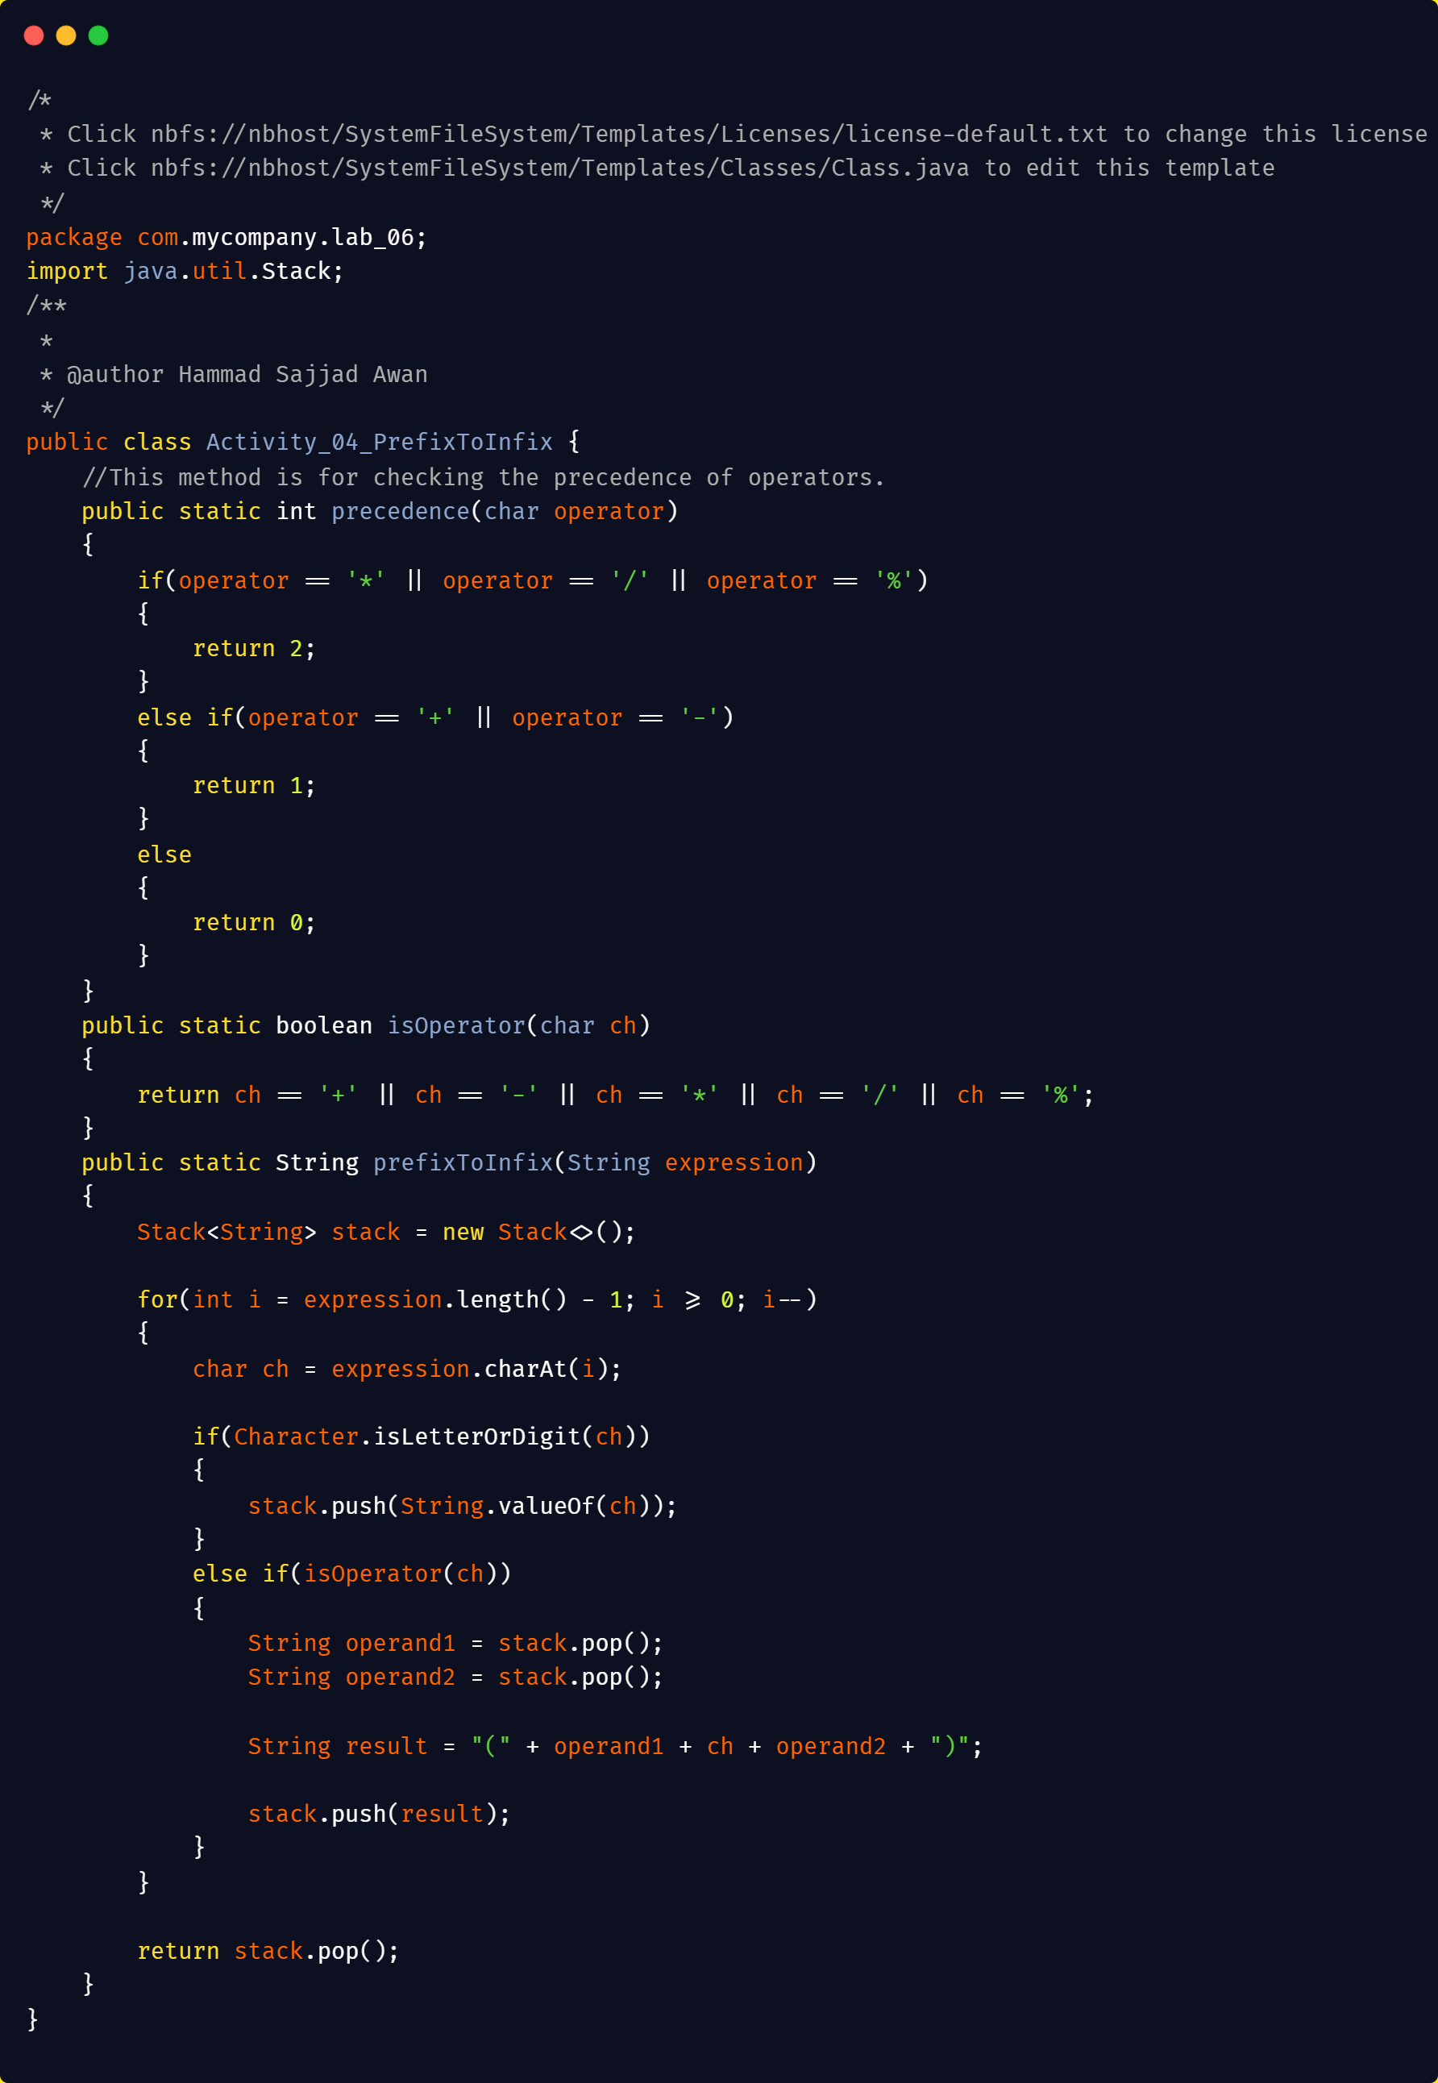
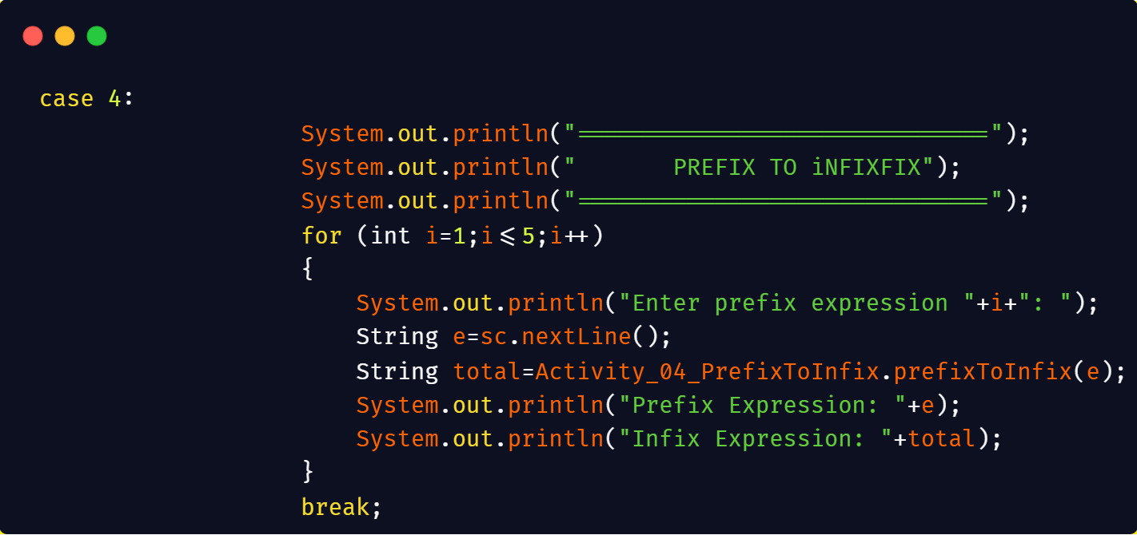
Output:
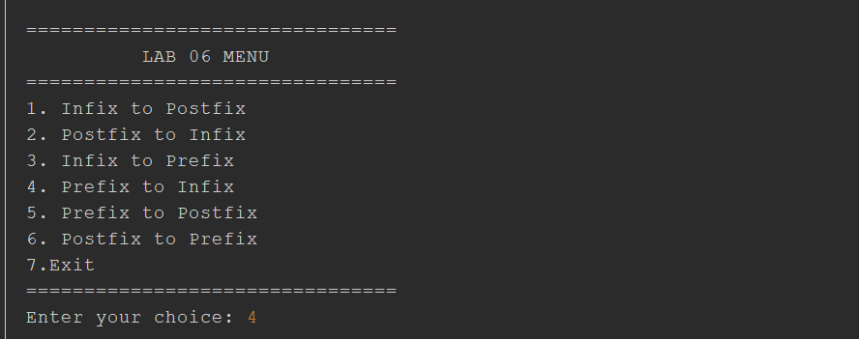
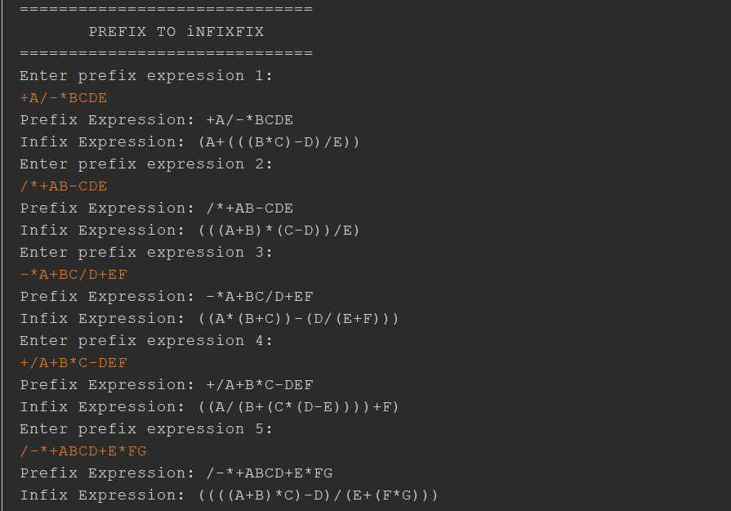
Lab Activity 05:
Activity 5 — Prefix to Postfix
Task
Write a Java program that converts a Prefix expression into Postfix notation using a Stack.
Implement:
prefixToPostfix(String expression)
Basic Algorithm
Read the Prefix expression from right to left.
- If the symbol is an operand, push it onto the Stack.
- If the symbol is an operator:
  - Pop the first operand.
  - Pop the second operand.
  - Combine them with the operator.
  - Push the resulting expression back onto the Stack.
- Continue until the expression ends.
- The final Stack element is the Postfix expression.
Example
Prefix:
+ A * B C
Postfix:
A B C * +
Example 2
Prefix:
* + A B C
Postfix:
A B + C *

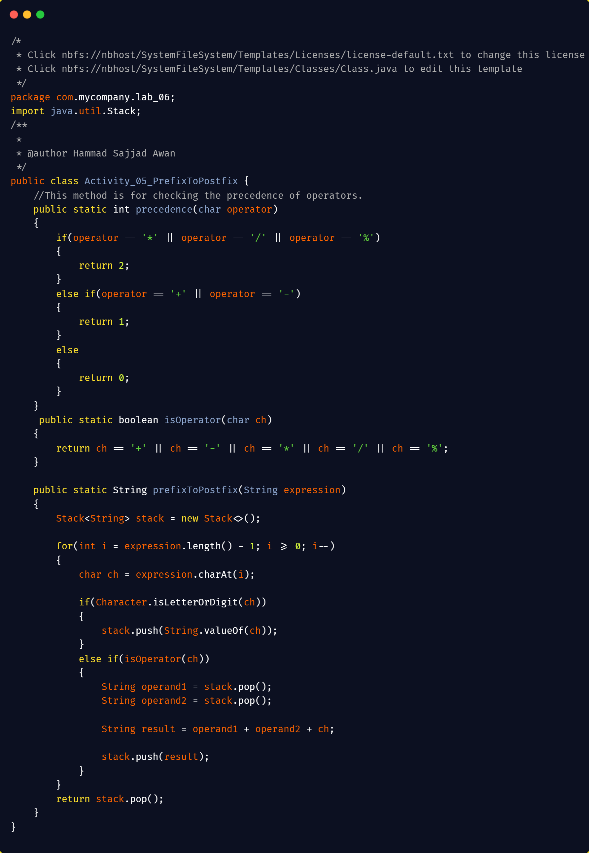
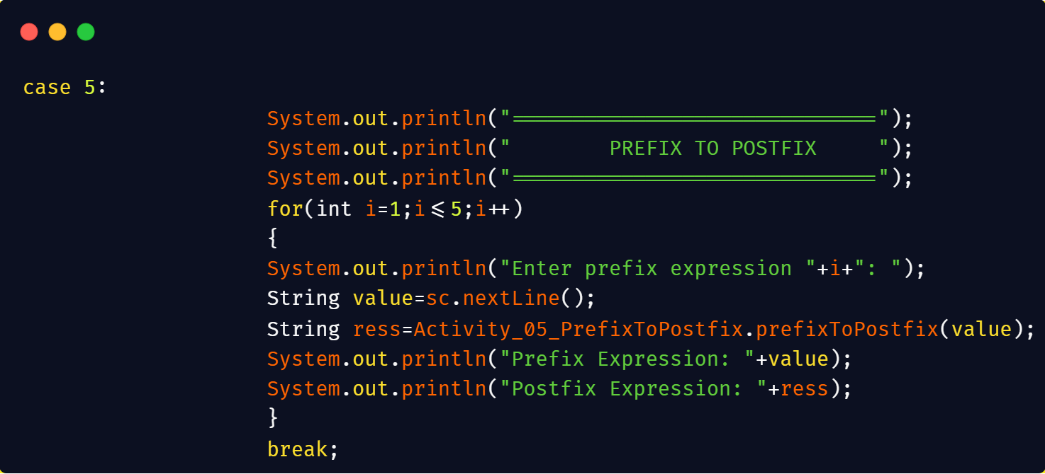
Output:
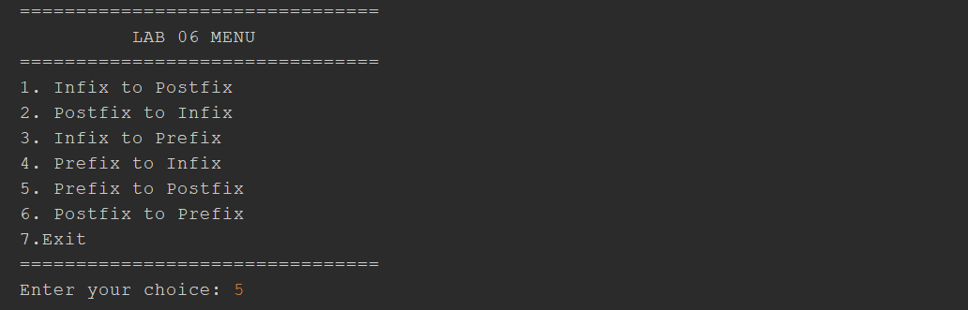
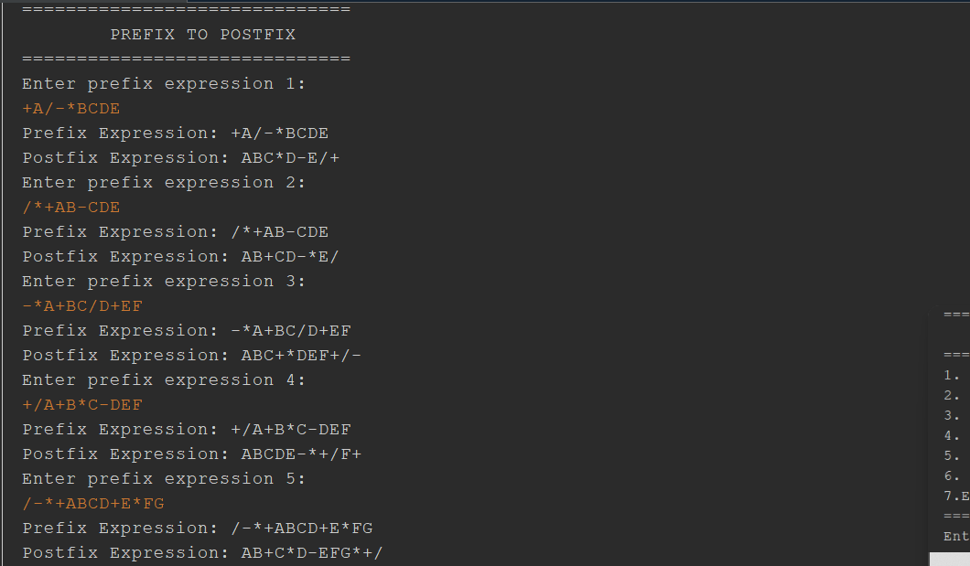
Lab Activity 06:
Activity 6 __ Postfix → Prefix

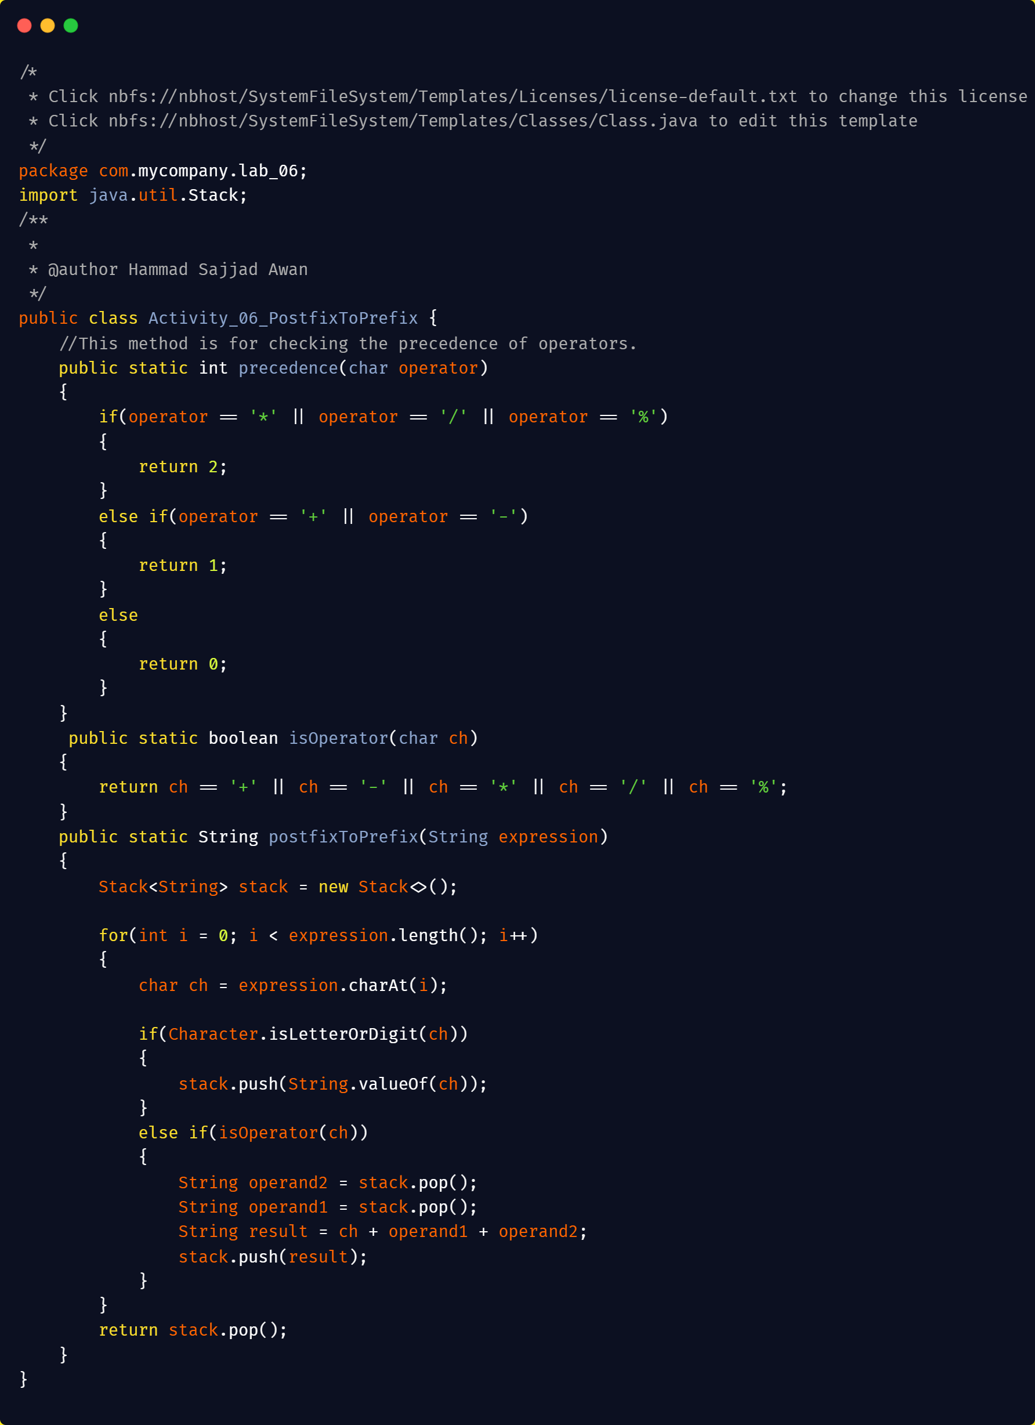
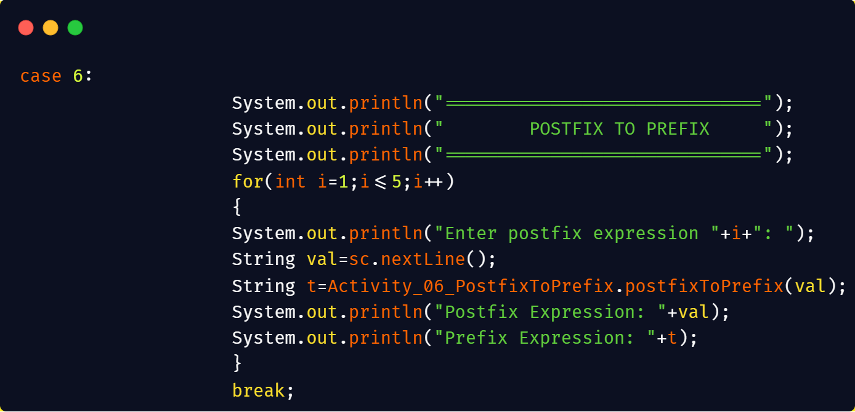
Output:
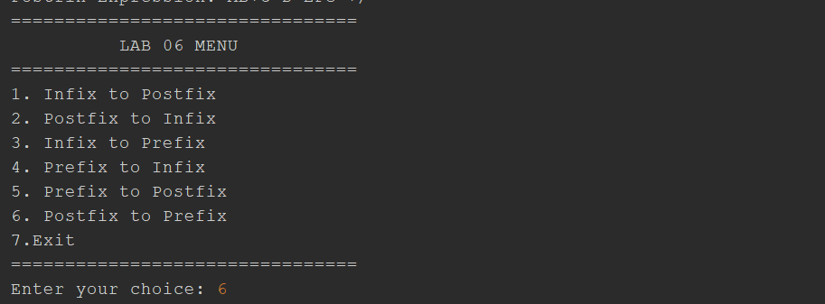
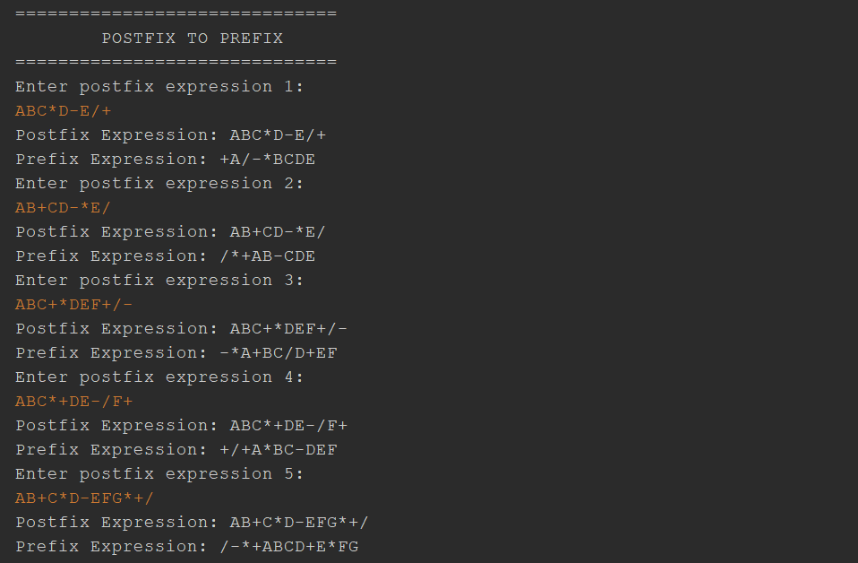
Exit:
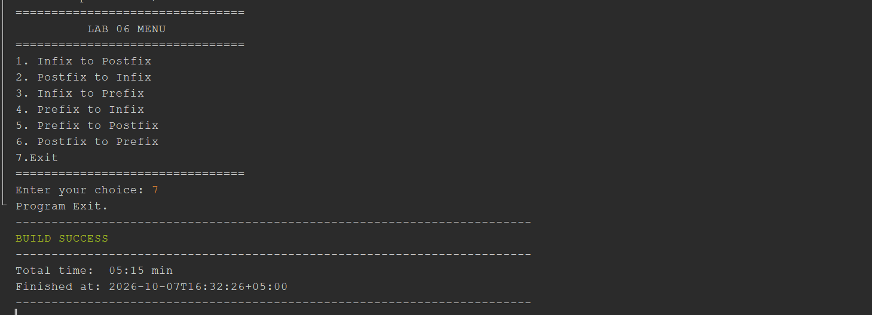
Main Menu:
Code:
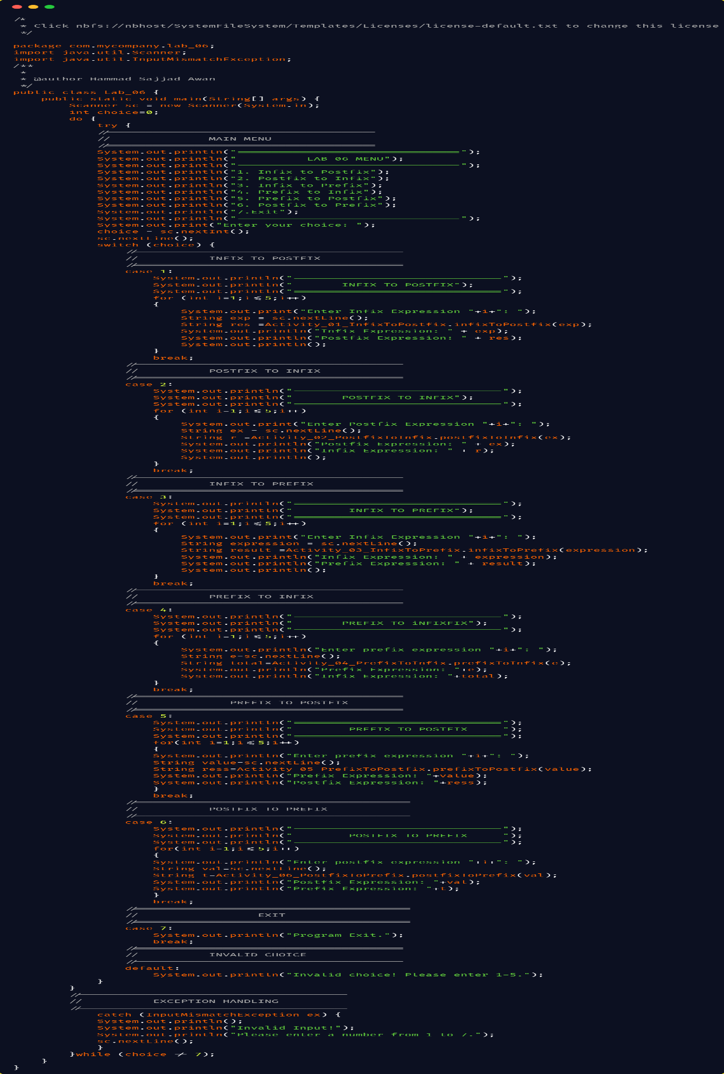
Output:
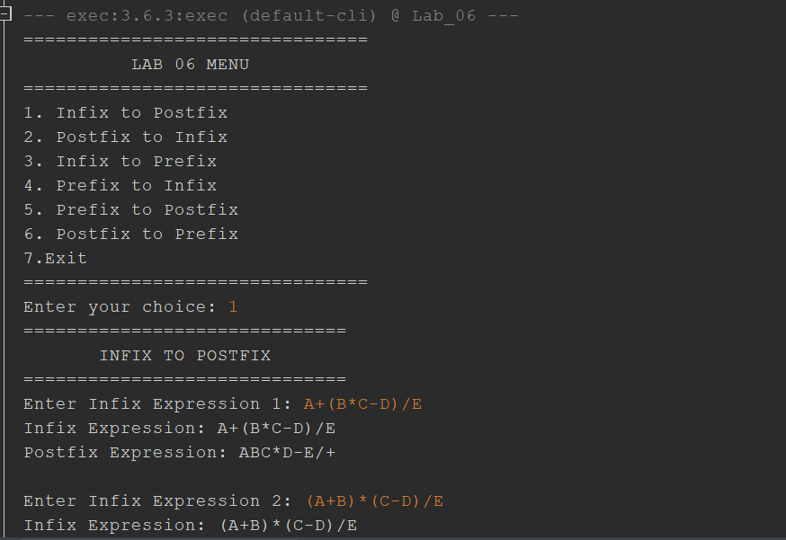
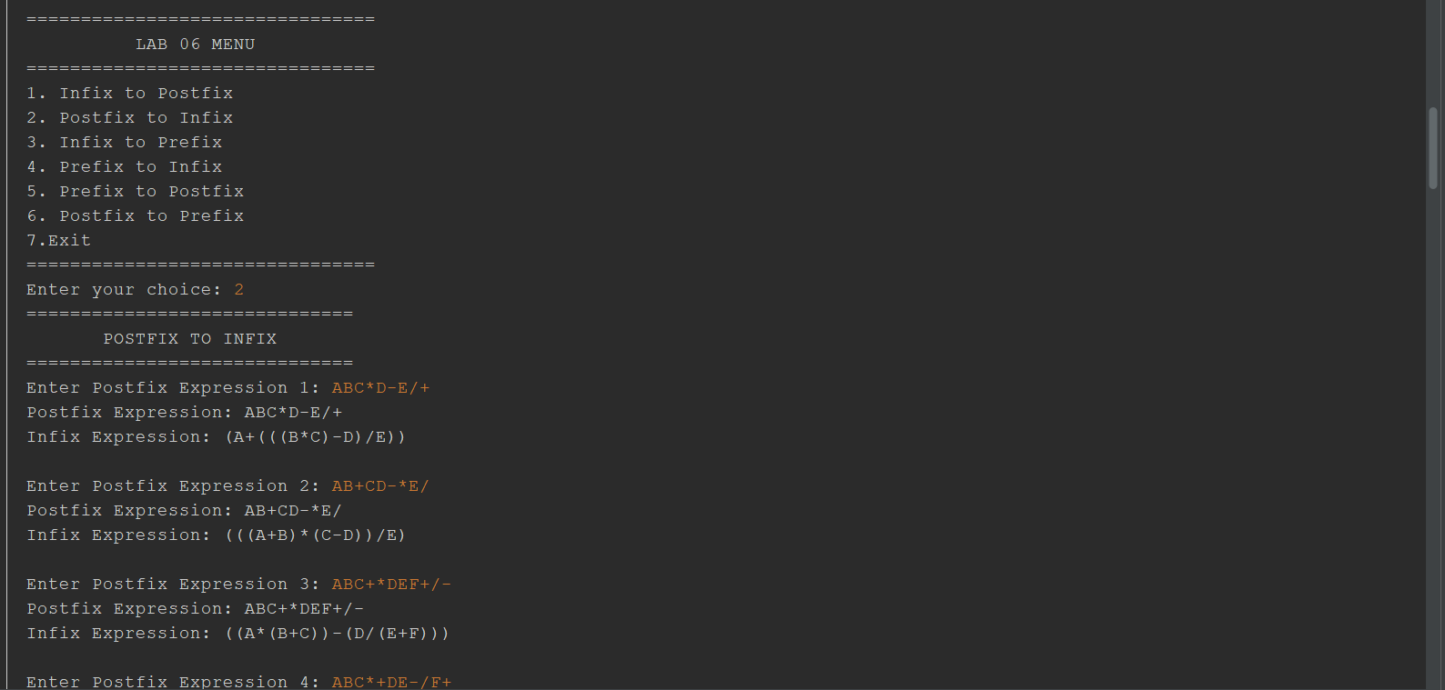

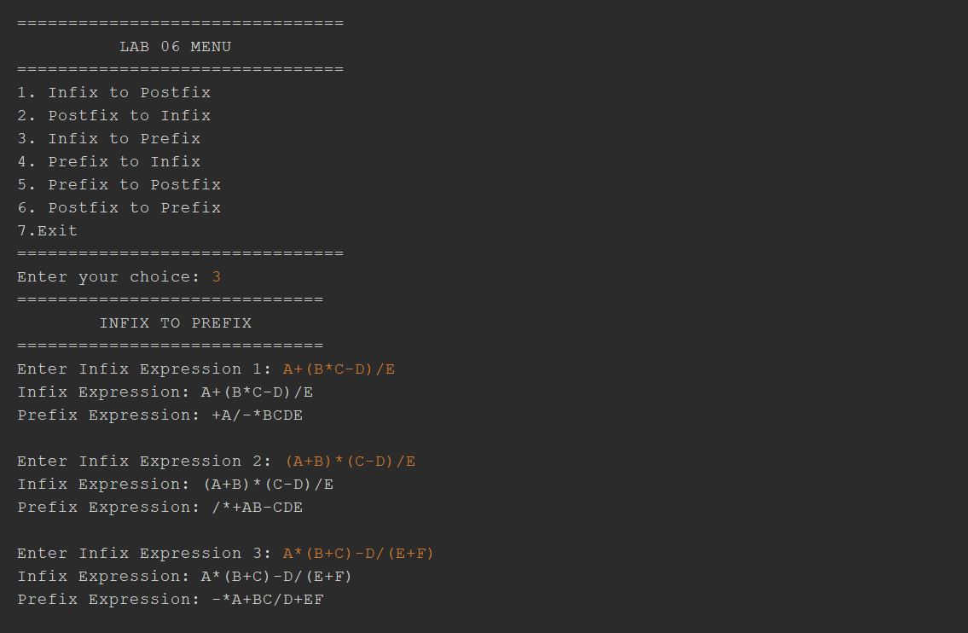
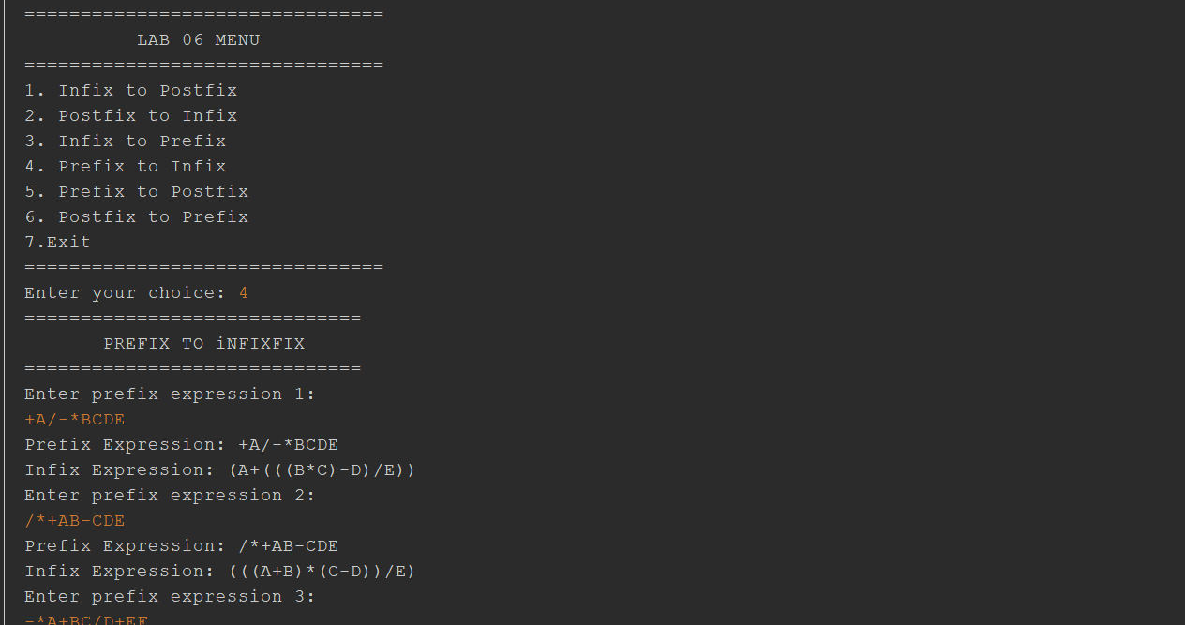

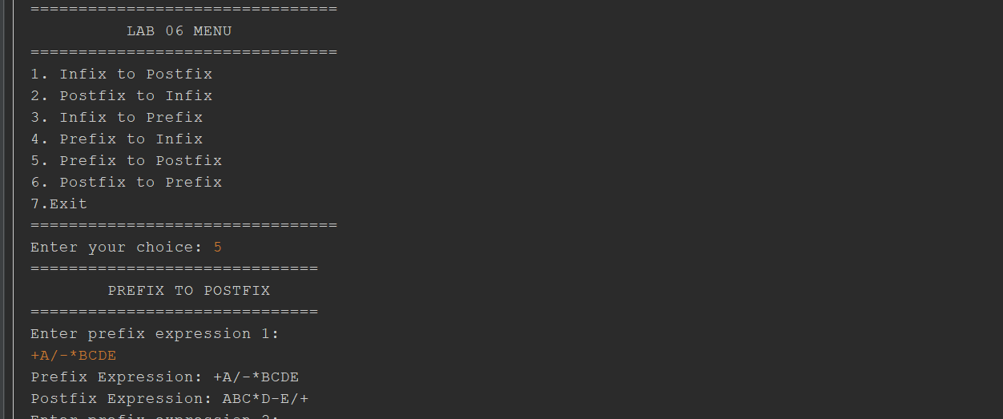
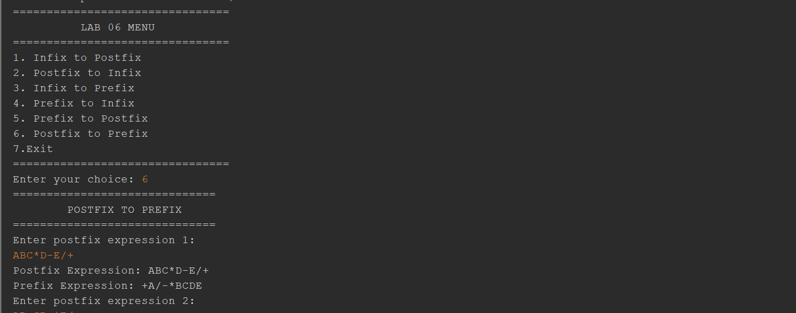
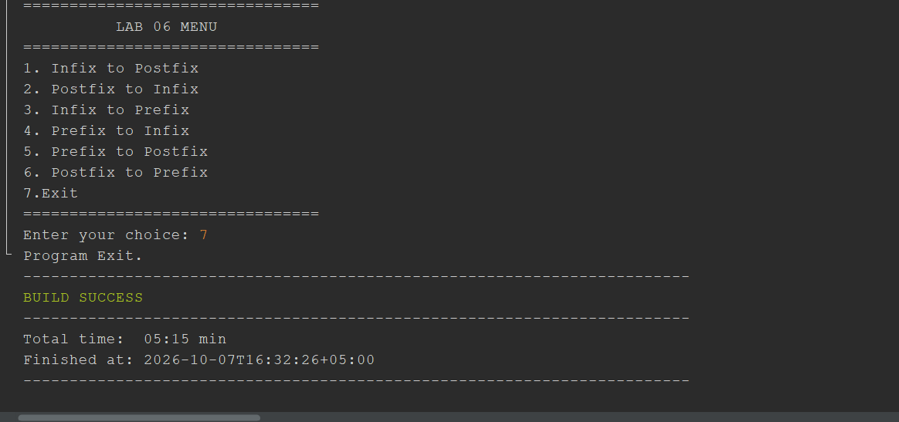
The End

